San Diego-based organizations receive funding to help reduce health disparities
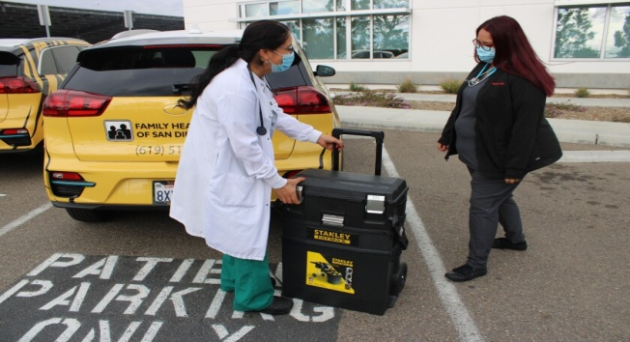
Nurse Maribel Marín with Family Health Centers and Wanda Ramírez, medical assistant with the Tiger Team. (Alexandra Mendoza - U-T)

Funds help ‘Tiger Teams’ reach out to the underserved

BY ALEXANDRA MENDOZAWRITER
JAN. 14, 2022 2:48 PM PT

Seventeen San Diego-based organizations recently received funding from the healthcare and insurance company UnitedHealthcare as part of an effort to reduce disparities and improve equity in health care access. One of the beneficiaries was Family Health Centers of San Diego. It used the funds to help establish a program to offer at-home medical services to low-income patients. The Tiger Team program, which began in September, serves Family Health Centers patients who are failing to meet certain key clinical metrics, either because of uncontrolled conditions or missing tests, due to pandemic-related barriers, such as fear of going to a hospital or clinic and lack of transportation and childcare, representatives said.

The target population includes low-income patients with hypertension, diabetes, high cholesterol, or people over age 50 with chronic conditions, and older adults who could be at risk from COVID-19.
“What we are aiming to do is meet people where they are and provide them the critical services that they would need,” said Raquel Herriott, public relations specialist with Family Health Centers.
The Tiger Team program, established in response of the pandemic, seeks to ensure that patients receive the services they require in a timely manner.
Health personnel arrive at patients’ homes to perform checkups, such as diabetic foot or eye exams, or collect samples for lab work. Certain vaccinations are also offered.

The program uses two electric vehicles, in yellow with tiger stripes, equipped to provide basic primary care and vaccinations, among other services. From September through December, the program served about 200 FHC patients. In total, UnitedHealthcare made an investment of $1.5 million distributed among local organizations, including nonprofits, community and faith organizations, health centers, and educational institutions. These groups are: Interfaith Community Services, Champions for Health, Chicano Federation, San Diego County Promotores Coalition, San Diego Youth Services, Neighborhood Healthcare, South Bay Community Services, HealthCorps, SAY San Diego, La Maestra Community Health Centers, Cajon Valley Union School District, Oceanside Unified School District, San Diego Rescue Mission, TrueCare, San Ysidro Health and Father Joe’s Villages.

“We really looked at organizations whose mission intersected with ours, and who wanted to establish programs that improve health equity and access in underserved areas,” said Monique Knight, director of marketing and community outreach for UnitedHealthcare Community Plan. She considered that the pandemic shed an even brighter light on health equity and the challenges that many people face. “One example is getting to the doctor’s office,” she said. “If transportation is an issue, it affects access to healthcare, and Family Health Center’s Tiger Team program provides one solution to that particular challenge.”

